**Practical-7**

**Aim: Write a program using 8085 & verify for:**

1. Addition of Two 8-Bit Numbers.

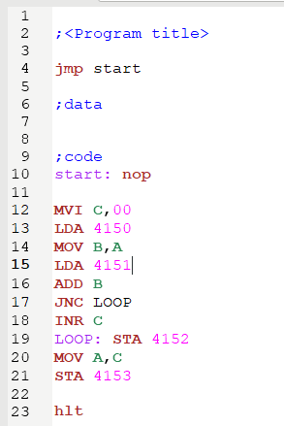 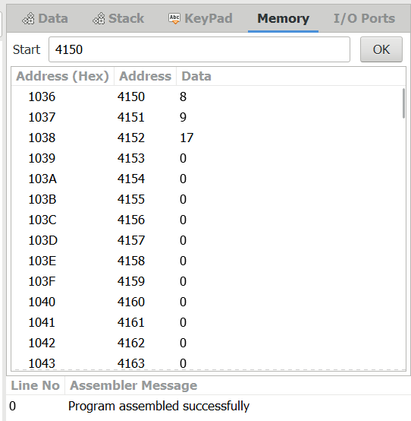

**2.** Addition of Two 16-Bit Numbers (With Carry):

